**Online Form Automation Execution Guide**

**Step 1: Extract the ZIP File**

Download the project ZIP file ([form_automation](https://redberyltech-my.sharepoint.com/:f:/p/apurva_narate/ElNvuPRZ6upPtV3gXZpw4x8BM67si0s2totg52b5mvsNpA?e=QWZF9o))

* Extract the contents of zip file into any directory of your choice
  + Selecting the download file
  + Right click on the selected downloaded zip file
  + Click on Extract All option from the pop-up menu

E.g. In below screenshot it is extracted at **downloaded and** **Downloads** folder.

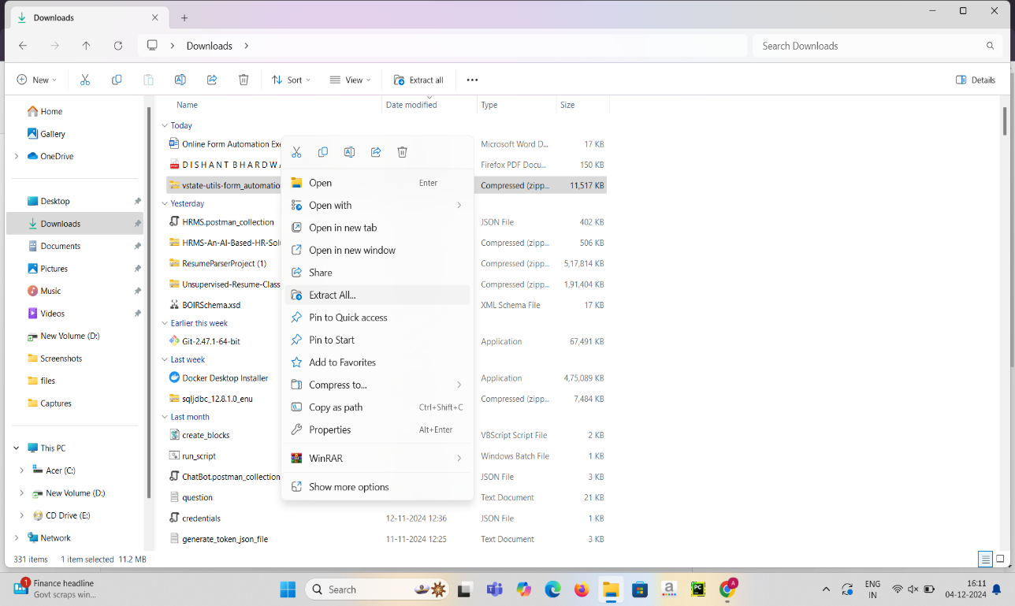

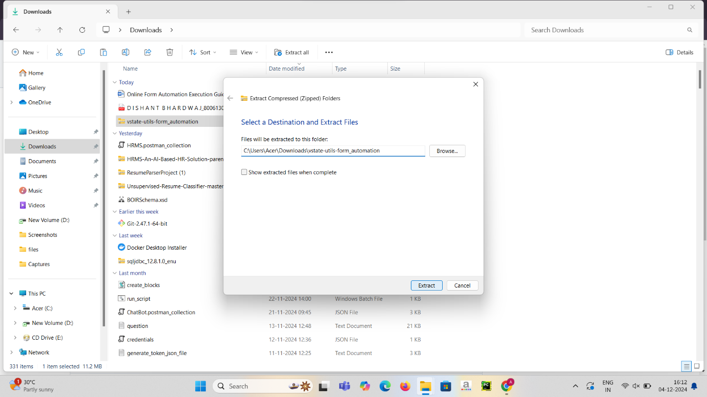

**Step 2: Configure the Project**

* Once extracted, go inside the extracted folder. You will find config.txt file.
* Open the config.txt file located in the project folder.

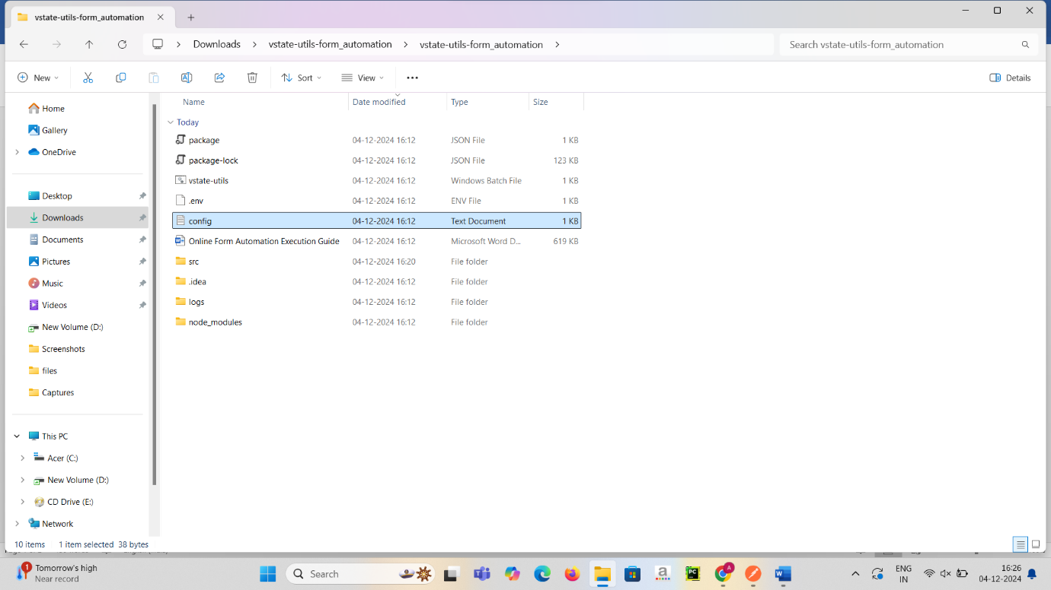

* Replace the existing path with our absolute path of the project directory as mentioned in the screen shot below as an example.

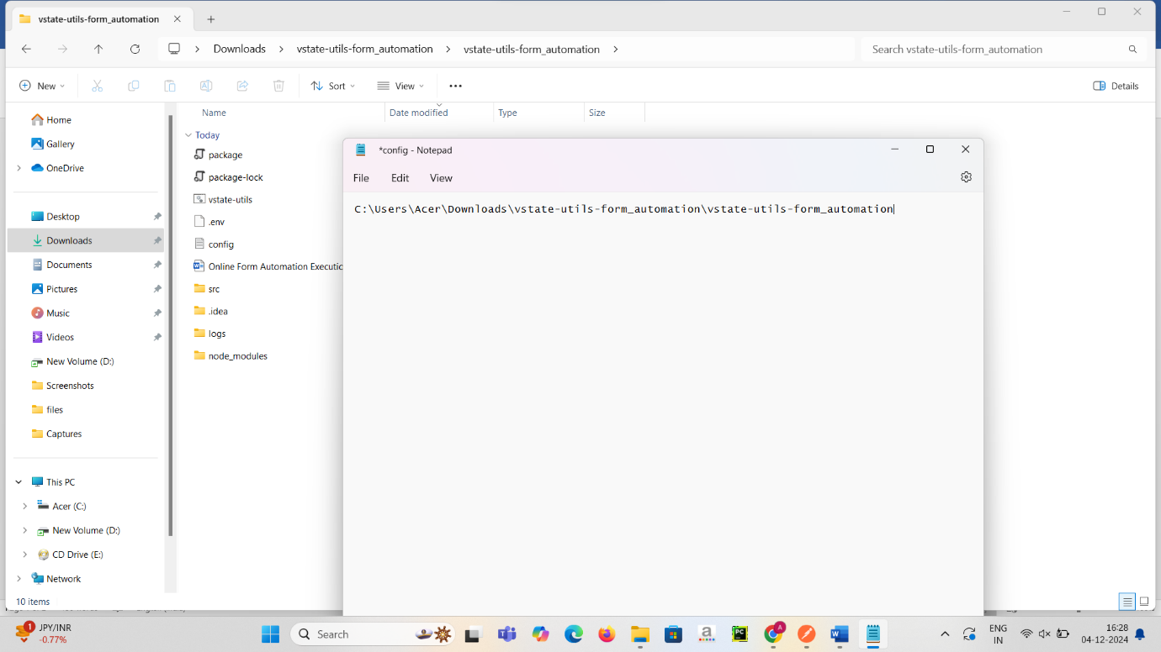

* Save this txt file with press ctrl + s
* 

**Step 3: Create a Shortcut for the Batch File**

* Right-click on the **vstate-utils.bat** batch file and select **Show more options**.

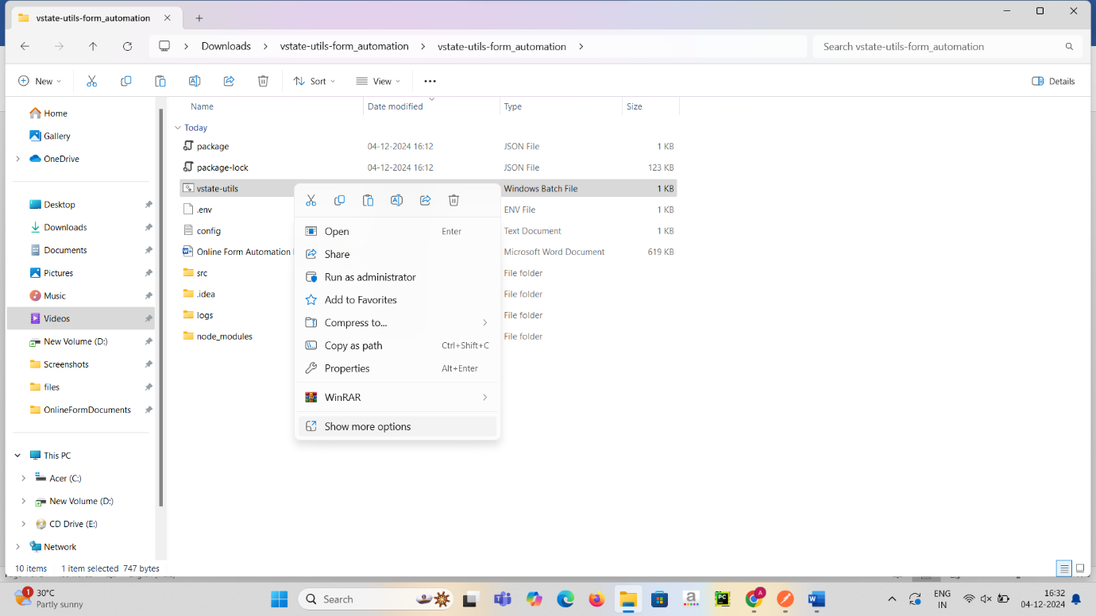

* Then Select **Create shortcut.** This will create a shortcut file at the same location. 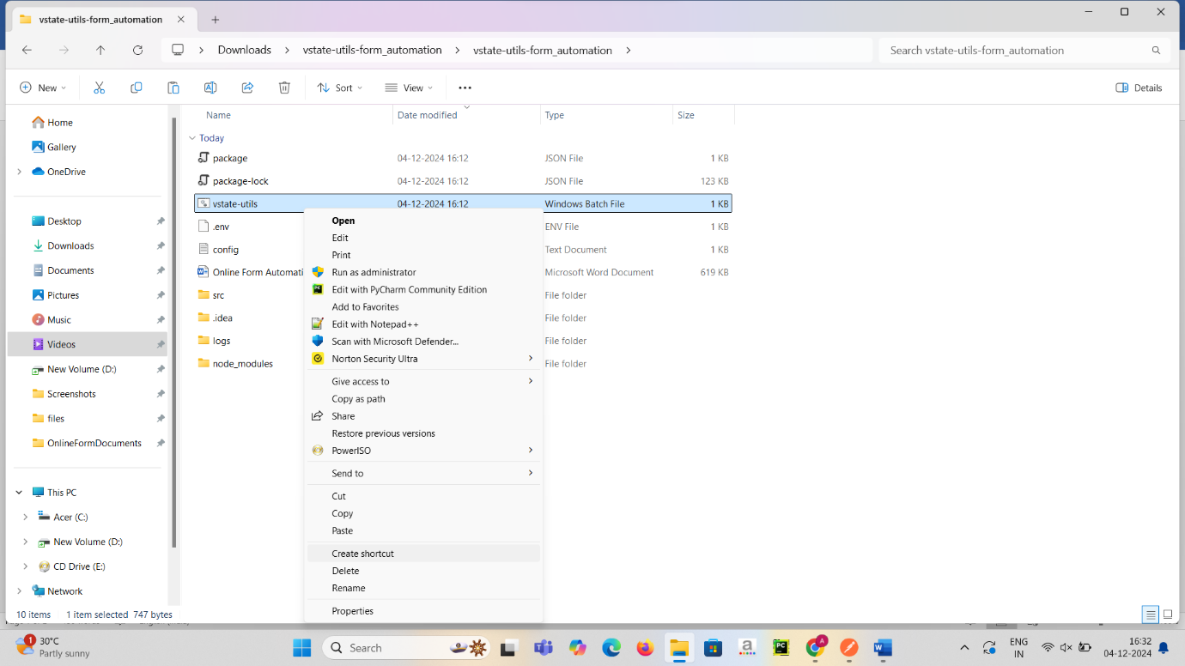

**Step 4: Add the Shortcut to Startup**

* Press Win + R to open the Run dialog box. (this will open a small window in corner)



* Type **shell:startup** in Run menu of Windows and press **Enter**. This will open the Windows Startup folder.

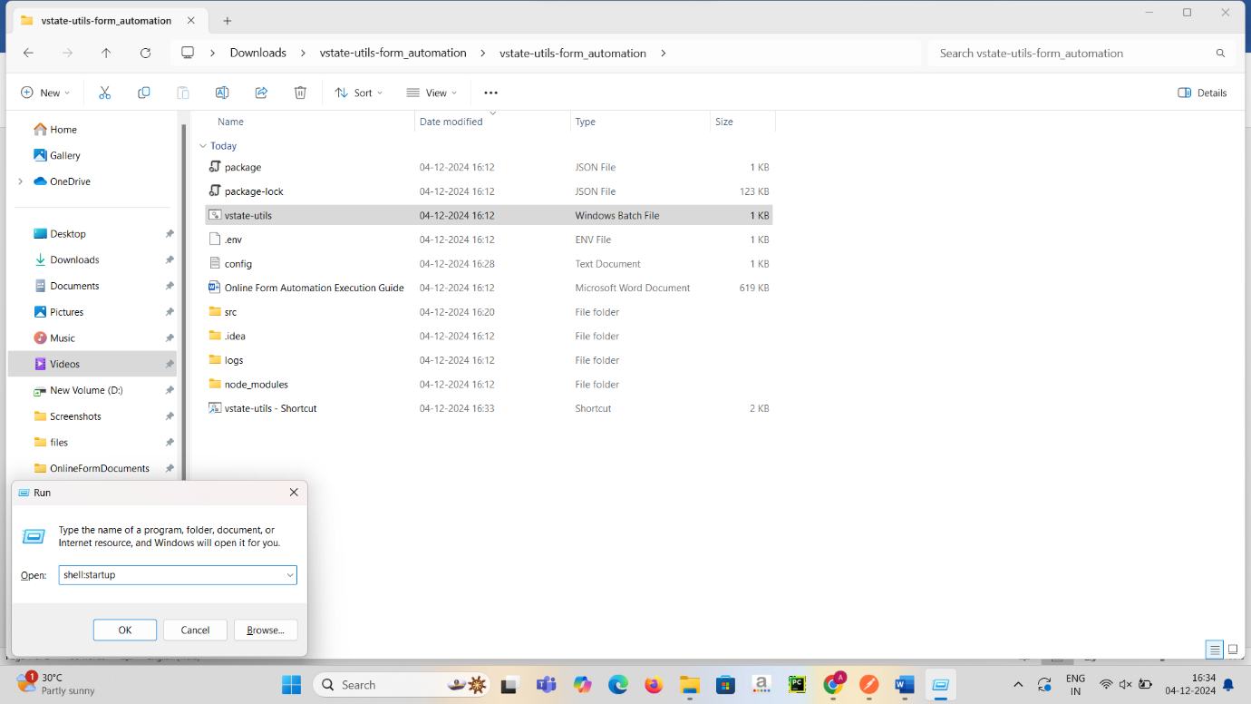

* Copy the created shortcut file which we created before in project folder.

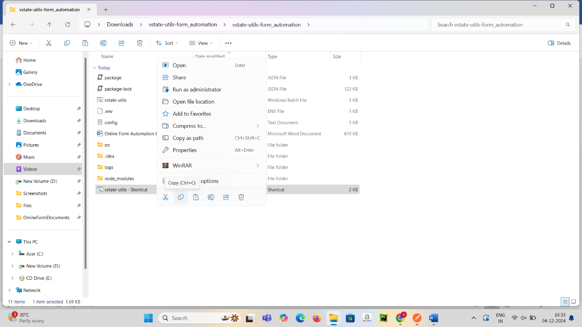

* And paste into the Windows Startup folder.

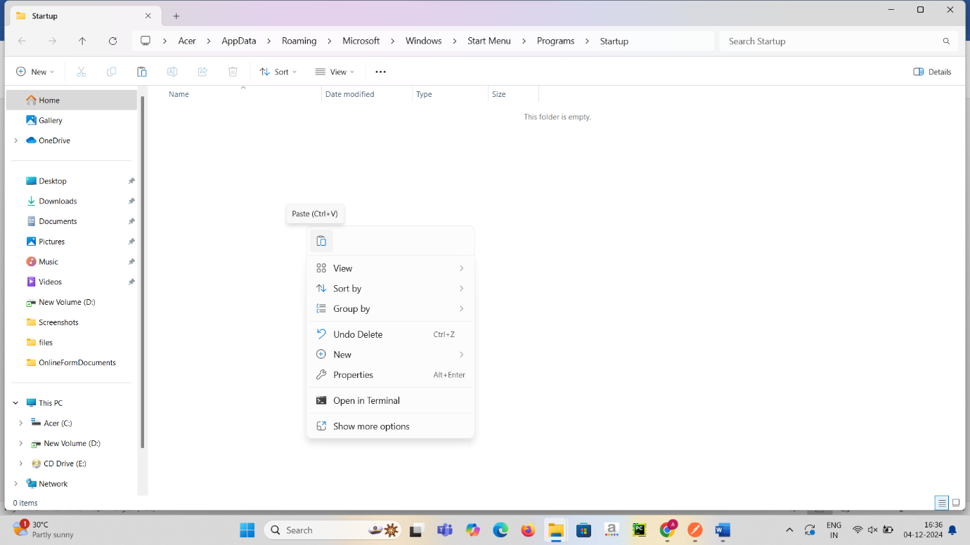

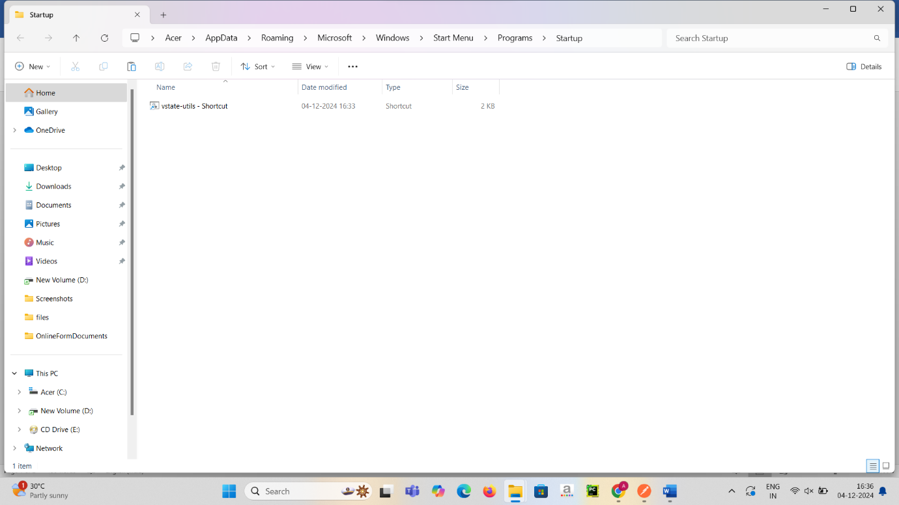

**Step 5: Verify the Setup**

* Restart your system to ensure the batch file runs automatically at startup.